

**Introduction to Computer Vision**

**Coursework**

**Submission 1**

**Your name HAO BAI____________**

**Student number 180223545___________**

**Question 1(a):**

Your image

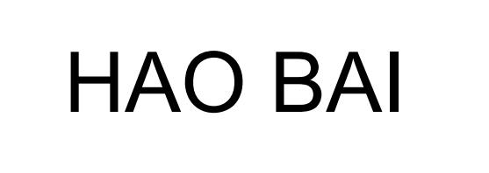

**Rotated images:**

θ = -50 deg

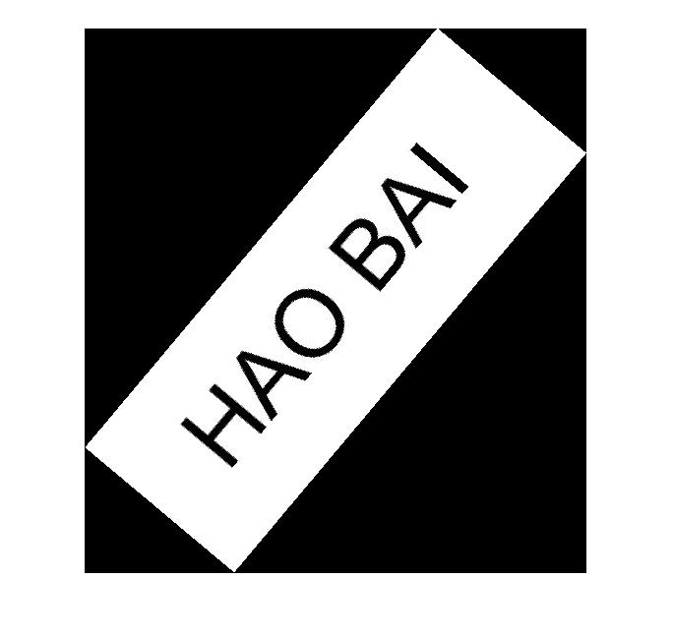

θ = 60 deg



θ = 30 deg

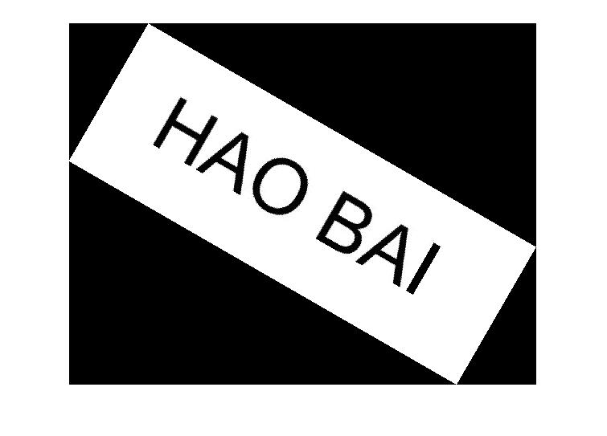

θ = 120 deg

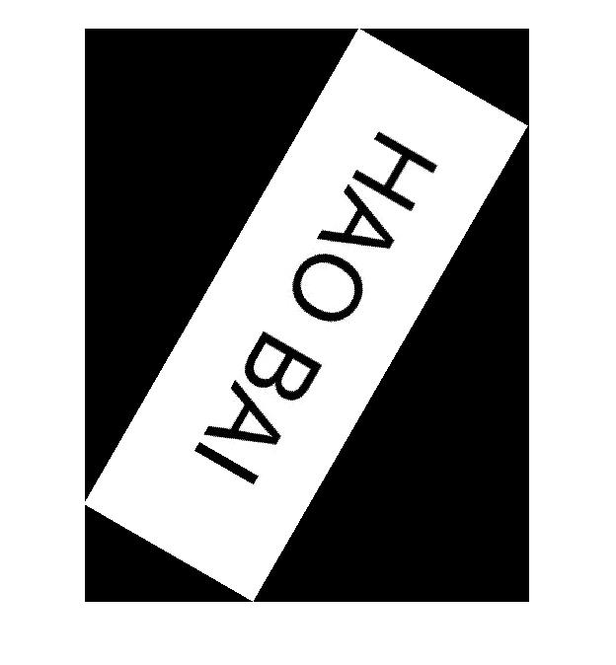

**Skewed images:**

θ = 10 deg

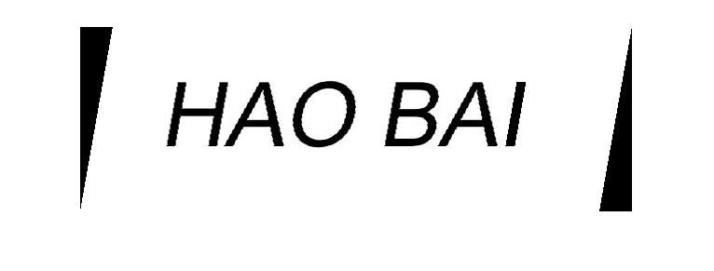

θ = 40 deg

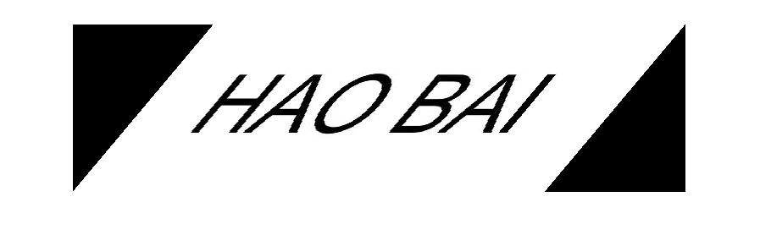

θ = 60 deg

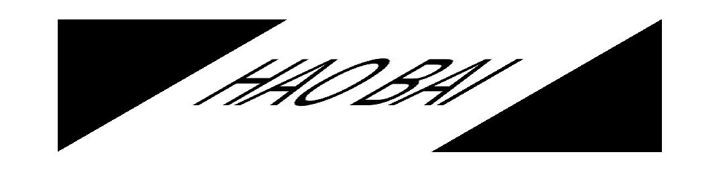

**Your comments:**

**The forward mapping is taken in this function. This function first calculates after mapping image hight and width. And create a new image.**

**Rotate:**

**New image hight = cos(theta) * Rows + Cols * sin(theta)**

**New image width = cos(theta) * Cols + Rows * sind(theta)**

**Skew:**

**New image hight =** **Rows**

**New image width = Cols + Rows * tand(theta)**

**And then find the maping point on the new image**

**Rotate:**

**Image (i, j) == new image (x, y)**

**X = (i - Rows_new/2) * cos(theta) -(j - Cols_new/2) * sin(theta)**

**Y = (j - Cols_new/2) * cos(theta) +(i - Rows_new/2) * sin(theta)**

**Skew:**

**Image (i, j) == new image (y, x)**

**y =i**

**x = j- i * tan(theta) + Rows*tan(theta);**

**After mapping all point of the orginal image, the complete rotated and skewed image can be seen in the result. Since the image needed to be shown as a rectangle, the no mapping part of the new image is set to black. The black part of the image is components of the new image**

**Question 1(b):**

θ2=50 and θ1=20 clockwise

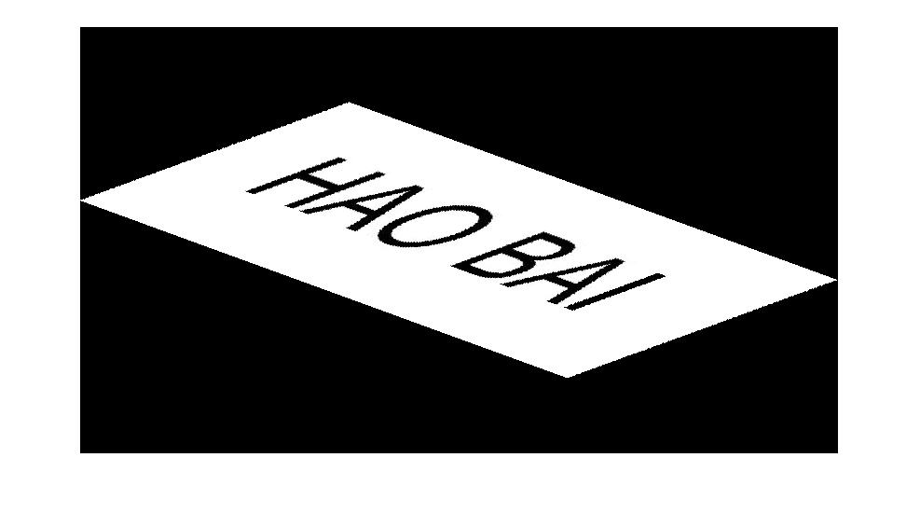

θ1=20 clockwise and θ2=50

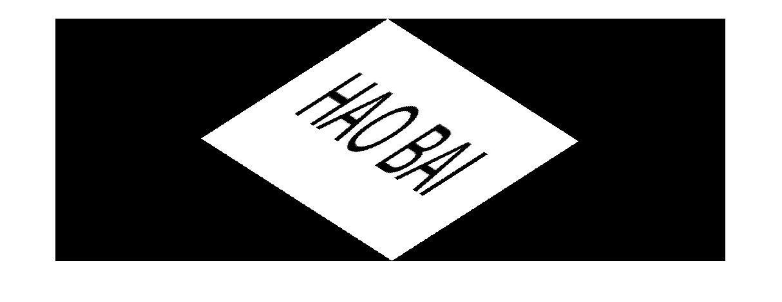

**Your comments:**

**The reason of the extra black part:**

**After the first function skew or rotate the image, the black part is a part of the result image. The second function skew or rotate is to implement changes on the result inage, not the orginal image. This caused the extra black part appeard.**

**Without black part, the shape of the image is same.**

**Reason:**

**Skew first Result image = (Rotate(Skew(image))) = (Rotate*Skew(image))**

**Rotate first Result image = (Skew (Rotate (image))) = (Rotate*Skew(image))**

**So:**

**Skew first Result image == Rotate first Result image**

**The result image without black part is same.**

**Question 2(a)**:

**Designed kernel:**

**1,1,1**

**1,1,1**

**1,1,1**

Averaged image

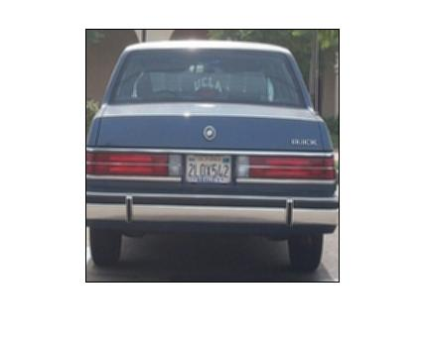

Original image

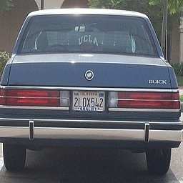

**Your comments:**

**The function is using the kernel to c**

**Function:**

**[x (k, l) **g (k, l)] **h (k, l) = x (k, l) **[g (k, l) **h (k, l)]**

**The result images are calculated through this funcion**

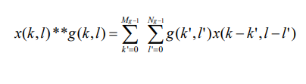

**The kernel is 1 1 1**

**1 1 1**

**1 1 1**

**The image will be blurrier.**

**Question 2(b):**

**Filtered image with kernel A**

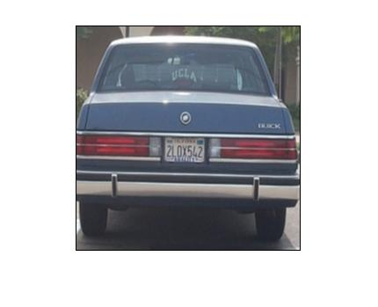

**Filtered image with kernel B**

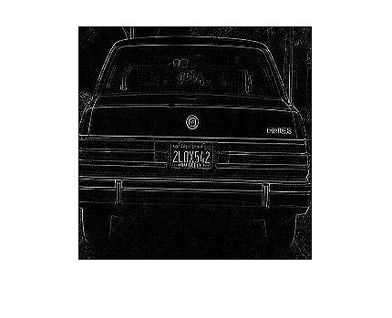

**Your comments:**

**The kernelA is the Gaussian blur.**

**The kernelB find the edge of the image and shown in black and white image.**

**Question 2(c):**

A followed by A

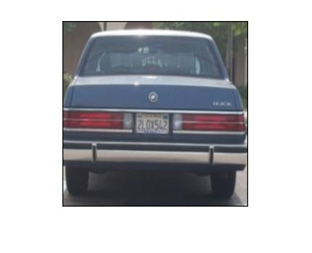

**A followed by B**

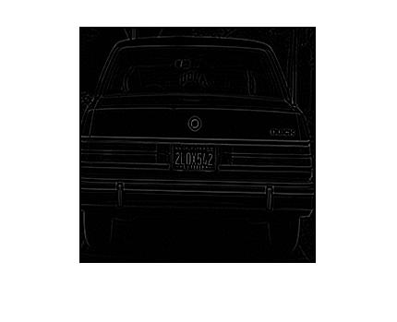

**B followed by A:**

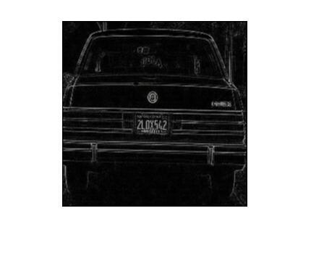

**Your comments:**

**The first image filtered the image by the kernal A followed by A. That made the image more blurred than using kernal A once.**

**The second image filterd the image by kernal A followed by B. That means that the filtering function will blurry the image first and then finds the edge of the result image.**

**The second image filterd the image by kernal B followed by A. That means that the filtering function will finding the edge first and then blurry the result image. The difference between is that the blurry first function will make the edge hard to find. As can be seen in the picture the edge of the B followed by A function image is wider than the blurry first one. However, the edge of the second image is more clear than the third one.**

**Question 2(d):**

**Extended kernels of A and B (5x5):**

**kernelA = [1,1,2,1,1**

**1,2,4,2,1**

**2,4,8,4,2**

**1,2,4,2,1**

**1,1,2,1,1];**

**kernelB = [0,0,0,0,0**

**0,0,1,0,0**

**0,1,-4,1,0**

**0,0,1,0,0**

**0,0,0,0,0];**

**Results obtained by applying 5x5 kernel:**

**B followed by A**

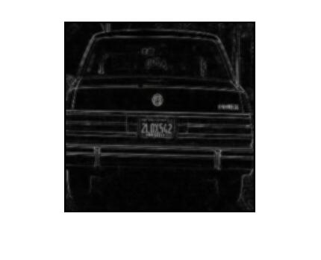

**A followed by B**

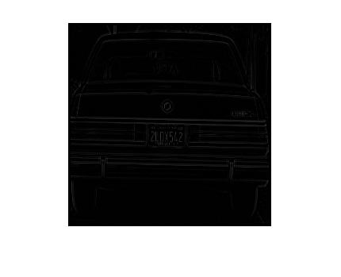

**A followed by A**

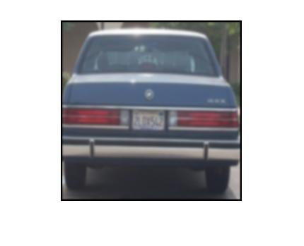

**Extended kernels of A and B (7x7):**

**kernelA = [1,1,1,2,1,1,1**

**1,1,2,4,2,1,1**

**1,2,4,8,4,2,1**

**2,4,8,16,8,4,2**

**1,2,4,8,4,2,1**

**1,1,2,4,2,1,1**

**1,1,1,2,1,1,1];**

**kernelB = [0,0,0,0,0,0,0**

**0,0,0,0,0,0,0**

**0,0,0,1,0,0,0**

**0,0,1,-4,1,0,0**

**0,0,0,1,0,0,0**

**0,0,0,0,0,0,0**

**0,0,0,0,0,0,0];**

**Results obtained by applying 7x7 kernel:**

**A followed by A**

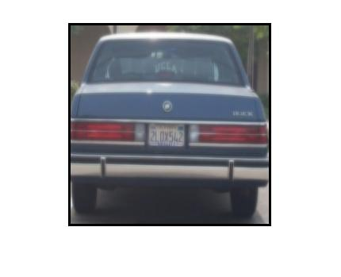

**B followed by A**

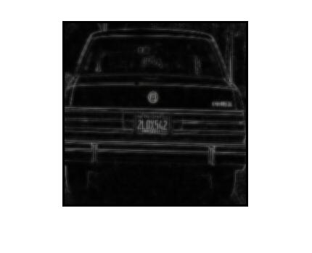

**A followed by B**

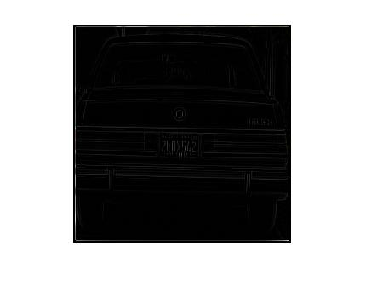

**Your comments:**

**5*5**

**kernelA = [1,1,2,1,1**

**1,2,4,2,1**

**2,4,8,4,2**

**1,2,4,2,1**

**1,1,2,1,1];**

**kernelB = [0,0,0,0,0**

**0,0,1,0,0**

**0,1,-4,1,0**

**0,0,1,0,0**

**0,0,0,0,0];**

**7*7**

**kernelA = [1,1,1,2,1,1,1**

**1,1,2,4,2,1,1**

**1,2,4,8,4,2,1**

**2,4,8,16,8,4,2**

**1,2,4,8,4,2,1**

**1,1,2,4,2,1,1**

**1,1,1,2,1,1,1];**

**kernelB = [0,0,0,0,0,0,0**

**0,0,0,0,0,0,0**

**0,0,0,1,0,0,0**

**0,0,1,-4,1,0,0**

**0,0,0,1,0,0,0**

**0,0,0,0,0,0,0**

**0,0,0,0,0,0,0];**

**Question 3(a):**

**Two non-consecutive frames:**

Image 1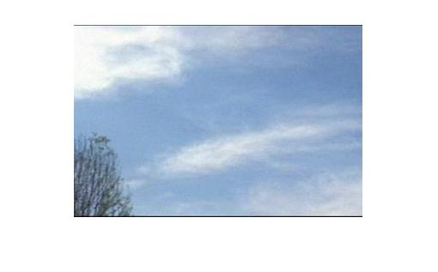

Image 2

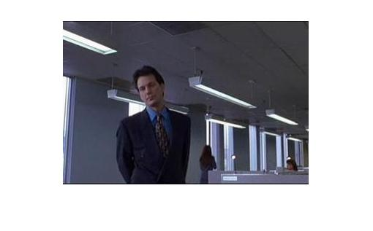

**Corresponding colour histograms:**

Histogram 2

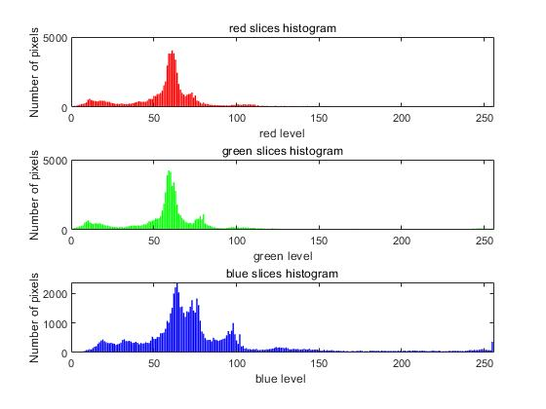

Histogram 1

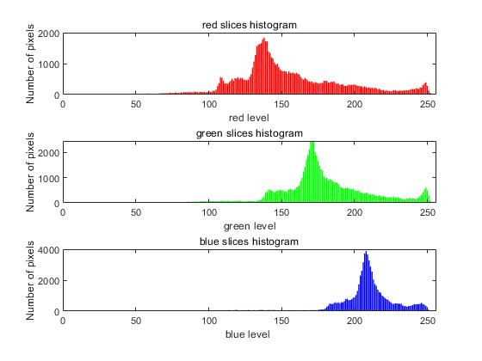

**Your comments:**

**The histogram is return the colour histogram of an input image. The x value is from 1 to 255 level. The y value is the number of pixels.**

**The red bar histogram represents the red layer on the image.**

**The green bar histogram represents the green layer on the image.**

**The blue bar histogram represents the blue layer on the image.**

**Question 3(b):**

**Example 1:**

It

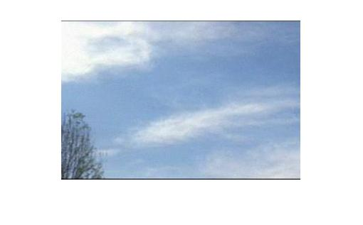

Frame3

It+1

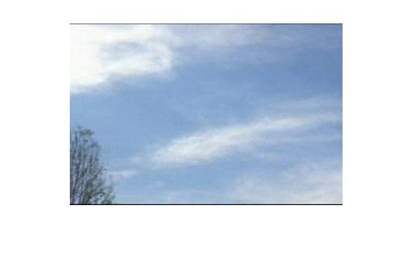

Frame4

**Histograms:**

Histogram of It

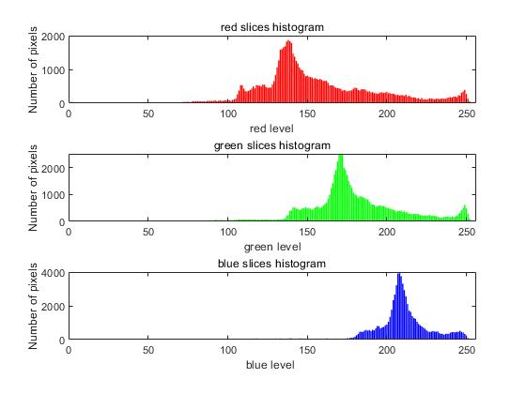

Histogram of It+1

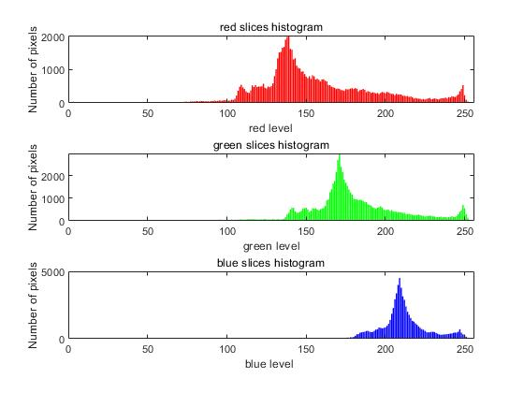

Intersection result

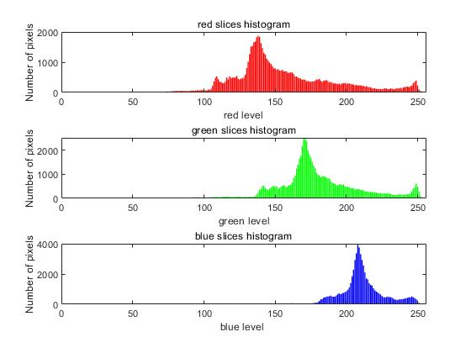

**Example 2:**

It+1

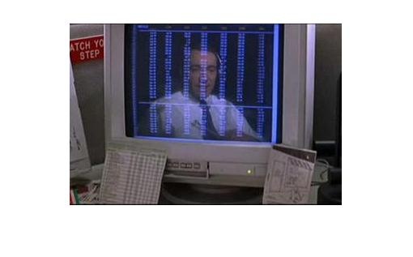

Frame10

It

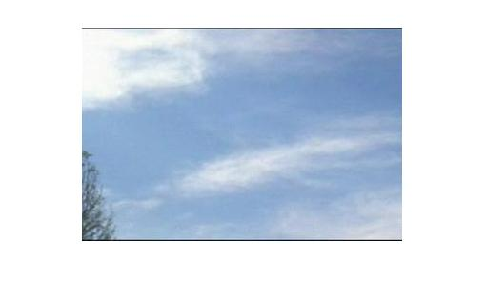

Frame9

**Histograms:**

Histogram of It

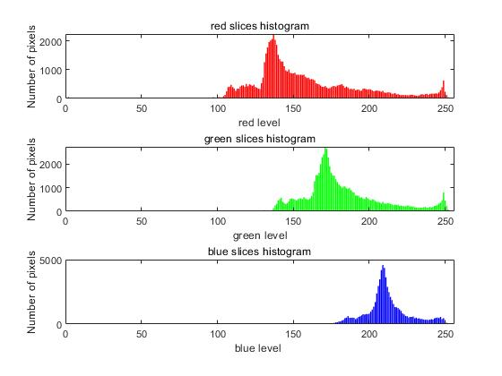

Histogram of It+1

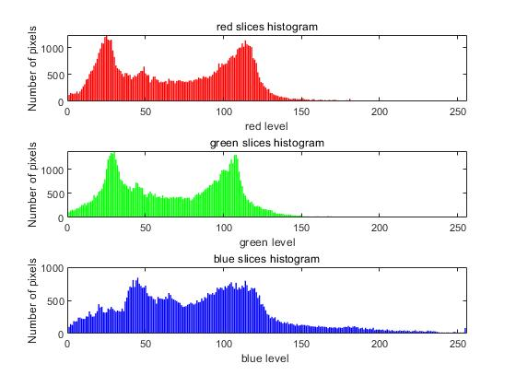

Intersection result

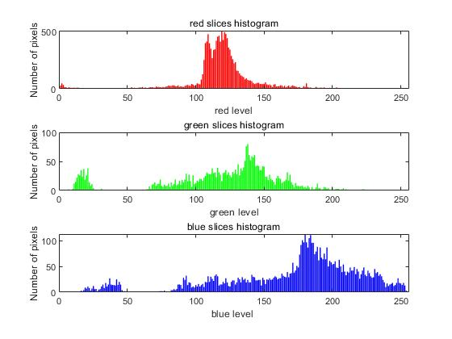

**Your Comments:**

**The Example 1 shows the consecutive frame RGB hisgram separately and the intersection of the two frames hisgrams. There are no scene changes on 3th and 4th frame of the video. However, the scene changes in frame 9th and 10th.**

**The intersection is calculate by the C:\Users\Administrator\AppData\Local\Temp\1541286080(1).png, the intersection value is calculate by using the intersection/** **union of the two histogram.**

**intersection value :**

**Example 1 :**

**Red slice intersection value = 72627/77713 = 0.9346**

**Green slice intersection value = 72436/** **78086= 0.9276**

**Blue slice intersection value = 70942/** **79586 = 0.8914**

**Example 2 :**

**Red slice intersection value = 13120/** **137156= 0.0957**

**Green slice intersection value = 3146/** **147148= 0.0214**

**Blue slice intersection value = 6290/** **143942= 0.0437**

**Question 3(c):**

**Comments:**

The intersection can be used to reprecent the scene changes in the video. As can be seen in the intersection values changes, the scene not change intersection values closer to 1. However, the scene changes intersection values are less than 0.1. It is hyposised that the intersection values is very low the scene might be changed. On the contrary, if the scene changes the intersection values may not close to 1. The picture blow shows the two image have same histogram and the intersection values will equals to 1.

